**Sravani**

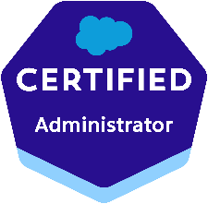 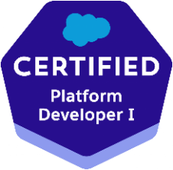 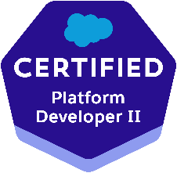 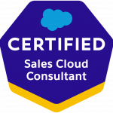 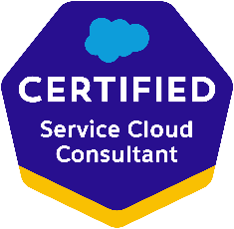 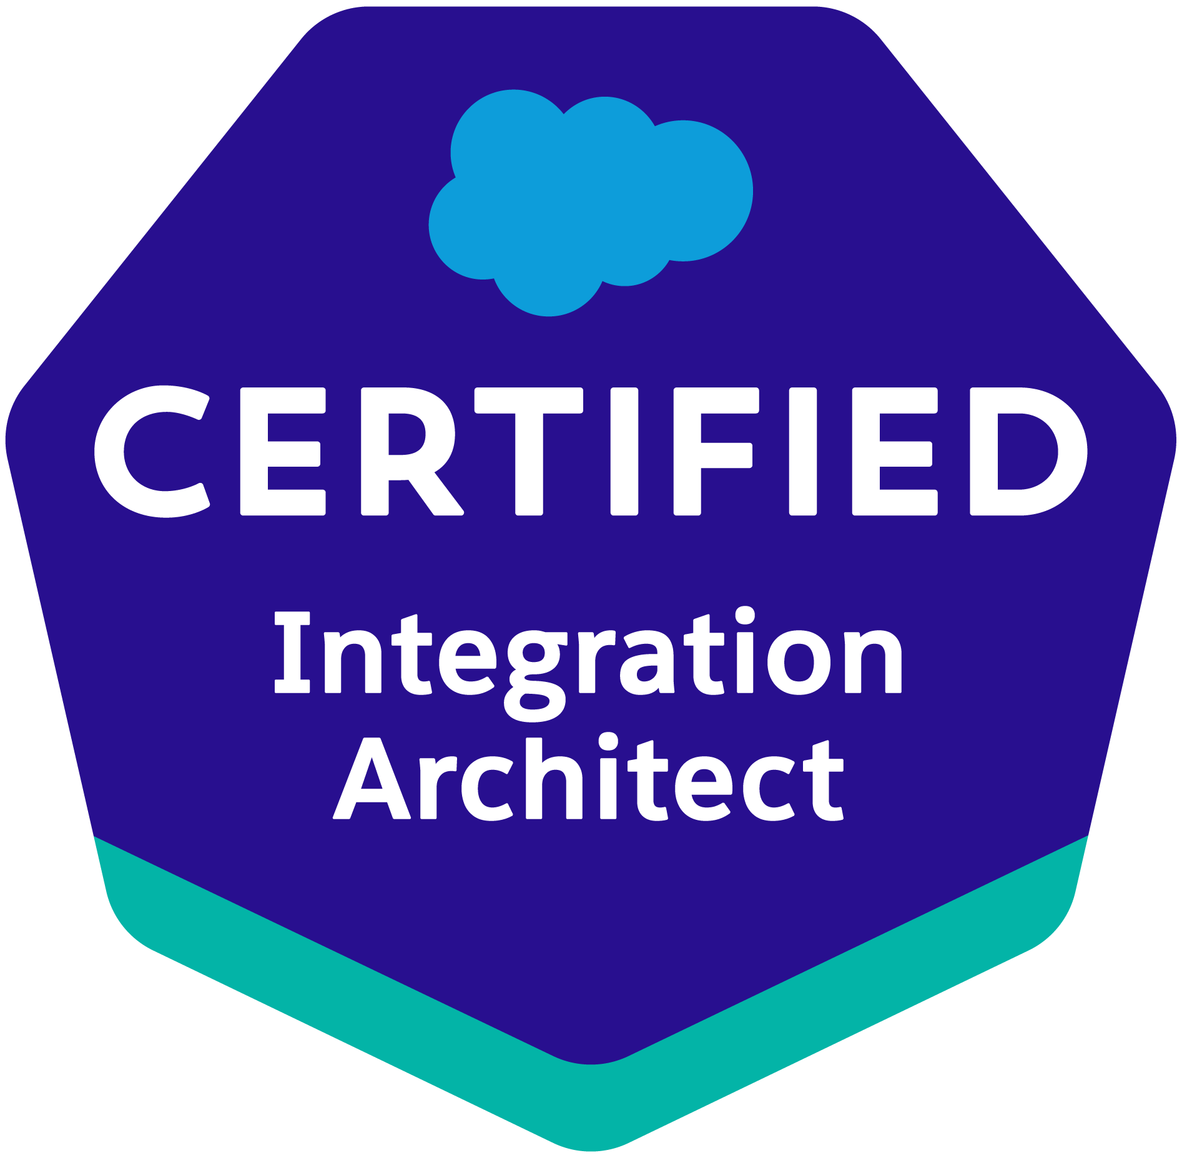

**Salesforce Developer**

**Phone:** +1 2142998373

**Email: Rishitha.23g@gmail.com**

**CAREER SUMMARY**

Results-driven Salesforce professional with 9 years of software development experience, including 7+ years specializing in Salesforce development, admin, and analytics. Proven expertise in building complex solutions and customizing Salesforce to meet business needs. Holds multiple Salesforce certifications, with proficiency in Lightning Web Components and strong HTML, CSS, JavaScript, and Apex skills. Committed to delivering high-quality solutions and continuously expanding knowledge in the Salesforce ecosystem.

**PROFILE SUMMARY:**

• Highly skilled Salesforce developer with over 9 years of IT experience, including 7 years of expertise in designing, developing, and deploying applications using Force.com, Apex, Visualforce, and Salesforce CRM.

• Proven track record in Salesforce CRM administration, configuration, implementation, and support, leveraging Soap API, Rest API, and Metadata API for seamless integration and enhanced functionality.

• Adept at configuring Salesforce environments, including activation of My Domain, component decomposition, and Lightning App development for optimal user experiences.

• Strong proficiency in modifying Visualforce pages to align with the Lightning Experience, coupled with a deep understanding of Lightning mode and its extensive features.

• Extensive experience and expertise in the Aura Lightning framework, encompassing the development of applications, components, controllers, and stylesheets.

• Successful implementation of Visual Flows and Process Builder to automate workflow actions based on specific functional requirements, streamlining business processes.

• Proven expertise in designing and developing Visualforce pages that cater to various functional needs within the Salesforce ecosystem, ensuring seamless and efficient web page design.

• Accomplished in creating Apex Triggers to address specific functional requirements and implementing Custom Controllers and Standard Controllers in Visualforce for enhanced customization.

• Proficient in utilizing Apex Triggers, Apex Classes, and Wrapper Classes, along with a comprehensive understanding of Visualforce pages, CSS, and JavaScript for robust development solutions.

• Trusted as a go-to resource for Salesforce administration support, including user management, security settings configuration, and sharing settings optimization.

• Demonstrated excellence in designing custom objects, custom fields, role-based page layouts, custom Tabs, and other components to meet unique client and application requirements.

• In-depth knowledge and hands-on experience with Salesforce standard objects, such as Accounts, Contacts, Opportunities, Products and Price books, Cases, Leads, Campaigns, Forecasting, Reports, and Dashboards.

• Proficient in configuring and customizing Salesforce for marketing needs, leveraging web technologies such as HTML, XML, CSS, AngularJS, JavaScript, and SOAP API.

• Expert in implementing robust security and sharing rules at the object, field, and record levels, ensuring appropriate access and data privacy for different users within the organization.

• Extensive experience with Apttus CPQ, overseeing design, estimation, quoting, rebates, incentives, and recommendations to streamline sales processes.

• Proven track record of working on diverse SFDC implementations covering Sales Cloud, Service Cloud, and Apttus CPQ, showcasing adaptability and deep knowledge of Salesforce development best practices.

• Highly experienced in application software designing, development, testing, administration, and implementation, with a specific focus on Salesforce technologies.

• Proficient in Salesforce configuration, customization, security access, workflow approvals, data validation, data utilities, analytics, and comprehensive administration in Salesforce CRM and Force.com Platform.

• Skilled in configuring and utilizing Apttus CPQ to effectively manage quoting, bundling, and product management processes.

• Expertise in standard Salesforce configuration techniques, including workflow rules, page layouts, record types, approval processes, assignment rules, validation rules, and bulk triggers.

• Proven experience in gathering functional and technical requirements, as well as designing prototypes, to deliver tailored Salesforce solutions that meet specific project objectives.

• Hands-on experience with Salesforce Lightning Builder and Lightning components, enabling the creation of modern and intuitive user interfaces.

• Proficient in Agile Methodology and Scrum Framework, ensuring efficient project management and timely delivery of high-quality Salesforce development solutions.

• Trusted for expertise in code review and release life cycles, driving code quality, and maintaining reliable application performance.

• Solid understanding of Salesforce Sales Cloud/Service Cloud and Force.com Administration/Configuration, Apex development, Force.com APIs, and data loading techniques.

• Skilled in different testing procedures and training aspects of Salesforce technologies, ensuring robust and reliable application performance

**CERTIFICATIONS:**

* Salesforce Certified Integration Architect
* Salesforce Certified Platform Developer II
* Salesforce Certified Platform Developer I
* Salesforce Certified Administrator
* Salesforce Certified Sales Cloud Consultant
* Salesforce Certified Service Cloud Consultant

**TECHNICAL SKILLS**

|  |  |
| --- | --- |
| **Salesforce Technologies** | SalesForce.com, Force.com, Sales Cloud, Service Cloud, LWC, Lighting components, CPQ, Apttus CPQ, Apex Language, Apex Classes/Controllers, Apex Triggers, SOQL, SOSL, Visual Force Pages/ Component, s-Control, Apex Web Services, Partner WSDL & Enterprise WSDL, Workflow and Approvals, Dashboard, Analytic Snapshots. |
| **Salesforce Tools** | Force.com IDE (Eclipse), AJAX Tool Kit, Force.com API tools (Data Loader), Force.com Explorer, Force.com Platform |
| **ETL Tools** | Data Loader, Salesforce-to-Salesforce, Apex- Explorer, Informatica. |
| **Languages** | Apex, C/C++, Java, J2EE, HTML, XML, CSS. |
| **Database** | SQL Server, Oracle, MySQL. |
| **Web** | HTML, XML, CSS, JSP, JavaScript, WSDL, SOAP. |
| **Tools** | MS Office, Adobe Photoshop, MS Excel, Silverlight, Eclipse IDE, RIVA. |
| **Web Servers** | IBM WebSphere 4.x/5.x, Apache Web Server, Tomcat 6.x |
| **Platforms** | UNIX and Windows (NT/2000/XP/Vista/7) |

**EDUCATION:**

* Masters in Computer Science – Governors State University, IL – 2016
* Bachelors in Electronics and Communications – JNTUH, INDIA - 2013

**PROFESIONAL EXPERIENCE:**

**Client: JPMC/Mphasis, NJ| Nov 2022 – Till Date**

**Role: Sr. Salesforce Developer**

**Responsibilities:**

* As a Salesforce Developer, I am serving as the technical leader in our projects, specializing in Lightning Web Components, Aura Components, Apex, Visualforce, and SOAP/REST-based service integrations.
* As a key member of Agile development teams, I am contributing to sprint planning, daily stand-ups, and retrospectives.
* Actively mentoring and sharing knowledge within the team, fostering a collaborative learning environment.
* Playing a pivotal role in refining user stories, ensuring clear acceptance criteria, and aligning with business objectives.
* Enforcing Salesforce coding best practices and design patterns, overseeing the development lifecycle to ensure high code quality and maintainability.
* Leading the technical aspects of Salesforce development projects, specializing in Lightning Web Components, Aura Components, Apex, Visualforce, and integration of SOAP/REST-based services.
* Implementing end-to-end development of new applications on the Salesforce platform.
* Conducting thorough business analysis to gather requirements and define the application architecture.
* Customizing objects, fields, and relationships to align with application requirements.
* Implementing custom Apex code and triggers to enforce complex business logic within the application.
* Integrating the new application with existing Salesforce features and third-party systems for seamless data flow.
* Optimizing Case page layouts to improve user experience and streamline the case resolution process.
* Customizing page layouts based on user roles, ensuring relevant information is prominently displayed for different teams.
* Integrating Riva with email systems to ensure seamless synchronization of emails, real-time updates between Riva and Salesforce to maintain accurate and up-to-date information.
* Implementing Email-to-Case functionality to automate the creation of cases from incoming emails, reducing manual data entry and improving response time.
* Implementing record types to segment data and streamlining processes based on different business scenarios.
* Configuring page layouts, picklist values, and business processes specific to each record type.
* Configuring and optimizing email processing rules to categorize and prioritize cases based on predefined criteria.
* Developing custom reports and dashboards tailored to specific business needs, providing real-time insights into key performance indicators.
* Using sandboxes for development and testing activities to avoid impacting the production environment.
* Creating and modifying code, configurations, and customizations within the sandbox environment.
* Integrating Salesforce sandboxes with version control systems to manage and track changes in code.
* Implementing secure authentication mechanisms, utilizing OAuth for REST API or Username-Password flow for SOAP API to ensure a reliable connection between the Java application and Salesforce.
* Actively implementing and leveraging hands-on experience with Version/Source Control and Continuous Integration tools for streamlined processes.
* Driving efficiency by implementing and overseeing automation testing frameworks, significantly reducing manual testing efforts.
* Creating and maintaining technical documentation for developed features, ensuring comprehensive knowledge transfer and seamless integration with other components.

**Environment**: Saleforce.com platform, Apex Language, Visualforce, Salesforce Lightning, Workflows, Reports, Dashboards, Service Cloud, Custom Objects, Custom Tabs, Jules, AWS, Filenet, Web-to-Case, Dynatrace, Terraform, Spinnaker, Octagon, GCP, JPM Private Client Case Tool Data Mapping, Splunk, Email-to-case, RIVA, Web Services, Sandbox, GitHub, Jenkins.

**Client: Mindray North America, NJ| Aug 2020 to April 2022**  
**Role: Sr. Salesforce Developer**

**Responsibilities:**

* Played a pivotal role in Salesforce.com Application Setup and customization activities to align applications with organizational functional needs within the telecom industry. Experienced Salesforce Data Architect Reporting professional with a proven track record in designing, implementing, and managing data architecture and reporting solutions within the Salesforce platform.
* Dedicated to ensuring data accuracy, integrity, and accessibility to drive informed decision-making and business success.
* Developed Lightning Components and server-side controllers to meet business requirements, including seamless migration of standard and custom objects from Salesforce Classic to Lightning Experience.
* Created app pages and home pages, integrating custom components for Salesforce Lightning and the Salesforce1 mobile app, while leveraging Apex, Visualforce, and AppExchange for custom application development.
* Designed and implemented modern Enterprise Lightning Apps, combining Lightning Design System, Lightning App Builder, and Lightning Component features, enhancing user interface and interaction.
* Collaborated with Solution Architects to architect and design complex solutions involving Salesforce and multiple integration endpoints.
* Leveraged web development experience in XML, Flex, JavaScript, SQL, C++, SOAP-based web services, HTML, and CSS to enrich Salesforce development projects.
* Enhanced Lightning Components by adding CSS and Design Parameters, ensuring a visually appealing user experience.
* Utilized Aura Framework, integrating Aura Attributes and Aura Handlers for Events to enhance logic and interactions within Lightning Applications.
* Performed maintenance tasks on installed Managed Packages in Lightning using Apex and utilized the Data Loader for data migration.
* Developed Visualforce Pages for Lightning Experience, offered alternate solutions for JavaScript codes, and facilitated the seamless transition between Classic and Lightning interfaces.
* Assisted in formatting and transitioning user data into Lightning Experience, while implementing Salesforce Lightning Components for specific user groups within the organization.
* Customized Lightning apps using Lightning Components to ensure compatibility with the Salesforce1 mobile app.
* Participated in migration estimation and analysis, ensuring a smooth transition from Salesforce Classic to Lightning.
* Utilized Lightning Process Builder flows, Connect API, Chatter, and Quick Action to enhance application functionality.
* Developed Lightning Component Tabs for Salesforce1 navigation and custom applications within the Lightning Experience.
* Implemented field-level security and page layouts in Lightning to manage access to specific fields.
* Collaborated closely with business users and product managers to capture requirements, translate them into system specifications, and develop new features and enhancements.
* Implemented Salesforce Development Cycle, covering Sales Cloud, Service Cloud, Call Center, Chatter, and AppExchange applications.
* Collaborated with stakeholders to gather and analyze business requirements, translating them into effective Salesforce data architecture and reporting solutions.
* Designed and maintained robust data models, objects, and relationships in Salesforce, ensuring data security and compliance with industry regulations.
* Implemented seamless data integration between Salesforce and external systems, enabling efficient data synchronization and maintaining data quality.
* Developed and customized reports and dashboards in Salesforce to provide actionable insights for various stakeholders.
* Conducted thorough testing of Lightning Applications by appending multiple components and deploying them from Sandbox to Production.
* Configured various reports and report folders based on user profiles to provide meaningful insights within the organization.
* Worked extensively in the service cloud, supporting cases, and developing workflows, and triggers for automated case resolution.
* Performed administrative functions in Salesforce CRM, such as modifying picklists and lookup fields, setting up chat agents, and managing security controls.
* Collaborated with prospects/clients to identify technical requirements and infrastructure for CRM-based enterprise solutions.
* Managed security controls by modifying sharing settings, field accessibility, password policies, session settings, and network access.
* Utilized deployment tools such as Change Set, Eclipse, and ANT for efficient deployment of Salesforce customizations.
* Provided comprehensive training to internal users, enabling them to effectively navigate the application, generate reports, and utilize system functionalities.

**Environment**: Saleforce.com platform, Apex Language, Visualforce (Pages, Component & Controllers), Salesforce.com Data Loader, Workflow & Approvals, Reports, Service Cloud, Custom Objects, Custom Tabs, Email Services, HTML, JavaScript, Web Services, WSDL, Sandbox, SQL Server.

**Client: AXA XL, CT | Dec 2019 to Aug 2020**

**Role: Sr. Salesforce Developer**

**Responsibilities:**

* Engaged with users to gather and document complex business requirements, ensuring a thorough understanding of their needs.
* Designed and developed Salesforce applications, adhering to Salesforce governor limits and optimizing data modeling.
* Prepared comprehensive documentation for the team, facilitating better system comprehension within Salesforce.com CRM.
* Utilized CPQ (Configure, Price, Quote) functionality to generate quotation Word documents directly from Salesforce.com.
* Contributed to end-to-end testing and configuration enhancements for CPQ (Configure, Price, Quote) and CLM (Contract Lifecycle Management) functionalities.
* Designed, developed, and maintained custom Salesforce applications using Salesforce DX tools and processes.
* Collaborated with the development team to streamline the Salesforce development process, improving efficiency and effectiveness.
* Developed and maintained CI/CD (Continuous Integration/Continuous Deployment) pipelines using Salesforce DX.
* Created custom objects, fields, validation rules, and formula fields to support specific business requirements.
* Developed Visualforce pages, Apex Triggers, Apex Classes, Test Methods, and Workflow to automate processes and customize functionality.
* Developed and customized reports and dashboards in Salesforce to provide actionable insights for various stakeholders.
* Established data quality standards, validation rules, and governance policies, resulting in improved data accuracy and reliability.
* Identified and resolved performance bottlenecks in data queries and reporting, optimizing data storage and indexing.
* Provided comprehensive training and support to Salesforce users, empowering them to create reports and conduct data analysis effectively.
* Maintained detailed documentation of data architecture, data models, and reporting processes to ensure transparency and knowledge sharing within the organization.
* Kept abreast of the latest Salesforce features, best practices, and industry trends related to data architecture and reporting, ensuring continued innovation and excellence.
* Implemented SOQL queries to extract data from Salesforce.com and synchronize it with the Right90 application, ensuring regular updates and accuracy.
* Configured Mule processes to retrieve data from topics and perform web service calls to the Mule ESB middle layer for processing, leveraging MULE API manager and RAML (RESTful API Modeling Language).
* Developed Lightning Web Components (LWC) and apps, integrating elements from the Lightning Design System, Lightning App Builder, and Lightning Component framework.
* Implemented Lightning components and server-side controllers to meet specific business needs, deploying Lightning web components (LWC) for select user groups.
* Utilized Visual Flow to automate user actions and present relevant information on screens.
* Leveraged Process Builder to invoke Apex methods for updating contact information based on zip code.
* Deployed Salesforce customizations using Force.com IDE, Change Sets, and Eclipse across sandbox and production environments.
* Provided solutions for Level-1, Level-2, and Level-3 support tickets, gaining experience in support projects.
* Developed scripts to load forecast data from Salesforce.com, ensuring accurate and up-to-date information.
* Created technical design documents and functional design documents aligned with business requirements.
* Implemented Web-to-Lead functionality in Sales Cloud to support online lead capture with auto-response rules.
* Developed integrations to integrate data from Salesforce.com using SFDC APIs.
* Designed and organized page layouts to optimize field placement, custom links, related lists, and other components on record pages.
* Configured fields and defined field dependencies for custom picklist fields.
* Implemented Case Assignment Rules to direct cases to appropriate groups, such as Stories and PCS Central Support.
* Developed Case Escalation Rules to escalate cases based on predetermined time frames and case complexity.

**Environment**: Apex, Visual force, Apex Classes, Apex triggers, Visual force, Pages, GitHub, Schedule Apex, Workflows, and Approvals, Data Warehousing, Case Management, Automation, Sandbox testing, SalesForce.com Platform, S-Controls,

**Client: Legal & General America, Maryland | May 2018 to Nov 2019**

**Role: Salesforce Developer**

**Responsibilities:**

* Identified, planned, and implemented new Salesforce.com features and functions (screens, workflows, force.com objects, reports, and Apex code) to align with business requirements.
* Utilized force.com IDE (Eclipse) for development and code promotion, ensuring efficient development practices.
* Developed batch interfaces and processes to seamlessly integrate Salesforce.com with external systems, improving data exchange and system interoperability.
* Proficiently utilized Data Loader and implemented Apex scheduler for scheduling timely data backup operations, ensuring data integrity and availability.
* Implemented escalation rules, automatic case generation, and escalation to call center representatives, streamlining issue resolution processes. Generated email alerts for prompt issue notification and resolution.
* Developed various custom objects, tabs, entity-relationship data models, validation rules, components, and Visualforce pages to support application development.
* Created triggers, Apex classes, and Visualforce pages as integral components of application development, enhancing system functionality and customization.
* Designed and organized page layouts and search layouts to optimize the arrangement of fields, custom links, related lists, and other components on a record detail and edit pages.
* Configured workflow rules and defined related tasks, time-triggered tasks, email alerts, and field updates to implement business logic and automation.
* Created templates, approval processes, and approval page layouts, defining approval actions to streamline and automate business processes.
* Established Master-Detail and Lookup relationships on standard and custom objects, utilizing junction objects to establish connectivity and relationships among objects.
* Developed Batch Apex code to handle progressed opportunities, efficiently processing large volumes of data.
* Implemented field-level security in conjunction with page layouts to control access to specific fields, ensuring data confidentiality and integrity.
* Conducted audits to identify and resolve data integrity issues with legacy systems, ensuring data accuracy and consistency.
* Developed comprehensive test suites for custom Apex code, ensuring robust code quality and performance.
* Extracted data from Salesforce.com into external databases (Oracle 10g) using Informatica on Demand, facilitating large data reports and analysis.
* Developed RAML resources to implement REST-based APIs as part of project implementation, enabling seamless integration with external systems.
* Engaged in data transformation and data cleansing activities during data transfer to external systems using Informatica on Demand, ensuring data quality and consistency.
* Established and maintained change control processes for multiple sandbox environments, ensuring a controlled and structured development environment.
* Collaborated with stakeholders to gather and analyze business requirements, translating them into Salesforce system functionalities.
* Conducted workshops and meetings to elicit user needs and preferences, ensuring a deep understanding of business processes and objectives.
* Designed and documented business processes, workflows, and system configurations to support Salesforce implementation and customization.
* Conducted user acceptance testing (UAT) and facilitated user feedback sessions to ensure system functionality meets business requirements.
* Assisted in change management activities, including communication, user adoption strategies, and post-implementation support.
* Supported data migration efforts, including data mapping, transformation, and validation, to ensure data accuracy and integrity in Salesforce.
* Assisted in the identification and resolution of system issues, working closely with the development team and stakeholders to provide timely solutions.
* Provided ongoing support and training to end-users, addressing questions, and concerns, and providing guidance on system usage and best practices.

**Environment**: Apex, Force.com, Triggers, API integration, Workflow & Approvals, Salesforce.com Platform, Web Services, HTML, CSS3, SQL, PL/SQL, JavaScript, jQuery, Oracle, SOAP UI, SOAP, API, Chatter, Sandbox data loading, Git, DML Query, Apttus CPQ and Web Service integration, Metadata API, SaaS/PaaS.

**Client: State of California, CA| Dec 2016 to April 2018**

**Role: Salesforce Admin/Developer**

**Responsibilities:**

* Collaborated with Business System Analyst to provide recommendations and design optimal solutions for implementing new business ideas.
* Focused on development, implementation, and updates in Sales Cloud and Service Cloud environments.
* Utilized Salesforce.com Standard Objects such as Accounts, Contacts, Opportunities, Campaigns, Cases, and Solutions.
* Created organized and intuitive Page Layouts, arranging fields, custom links, related lists, and components on record pages.
* Implemented advanced fields including Picklist Fields, Master-Detail Fields, and Custom Formula Fields, along with defining Field Dependencies for custom picklist fields.
* Configured Case Assignment Rules to streamline case routing to appropriate groups, such as Stories and PCS Central Support.
* Defined object and Field Level Security settings for different profiles, ensuring appropriate access controls.
* Developed an Apex Trigger on Contact for cross-object field updates, facilitating reporting functionalities.
* Enhanced Apex Classes and Visualforce Pages to create custom Related Lists, displaying activities for selected contacts or clients.
* Created and maintained Reports and Dashboards, enabling quick access to key business metrics and insights.
* Demonstrated expertise in providing live support activities and resolving issues for end users in a Production environment.
* Implemented Case Management by configuring Email-to-Case functionality, enabling end users to submit cases via Outlook.
* Customized and configured Email templates for PCS Central users, supporting approval processes and field updates.
* Customized Salesforce.com User Profiles, defining layouts for Standard and Custom objects, Custom Apps, Field-level Security, and Permission Sets for client services and marketing.
* Customized Chatter objects and tabs to track progress and facilitate discussions on business processes.
* Worked across different sandboxes for development and testing, ensuring smooth code migration to production instances using Change Sets.
* Configured Chatter integration with Outlook to track emails from Outlook to Salesforce by following a user.
* Utilized AppExchange Dup Catcher to effectively filter and prevent duplicate records within the organization.
* Responsible for regular data export, updates, and backups on a weekly and monthly basis.
* Leveraged Apex Data Loader to efficiently insert, update, and import data from Microsoft Excel into Salesforce.com.

**Environment**: SFDC, Apex, Data Loader, Force.com, Import Wizard, Eclipse IDE, Controllers, Visual Force Pages, XML, Triggers, API.

**Client: GET IT Pvt. Ltd – Hyderabad, India| April 2012 – July 2014**

**Programmer Analyst**

**Responsibilities:**

* Analyzing user requirements and business needs, designs and documents formal solutions, develops plans and procedures, and manages implementation of new and/or enhanced applications.
* Involved in research, evaluating and recommended solutions and appropriate technology to meet user's needs.
* Worked closely with the CIO to identify risks and to provide accurate time and cost estimates.
* Responsible for developing the full stack (front-end development, application logic, services, data persistence) as well as server setup and maintenance.
* Experience in writing programming scripts to enhance functionality and/or performance of company applications as necessary.
* Designed and developed various abstract classes, interfaces, classes to construct the business logic using C# .NET.
* Developed solutions by studying information needs, conferring with users, studying systems flow, data usage, and work processes; investigating problem areas; following the software development lifecycle.
* Updated and maintained the company website and intranet site and involved in organizing Custom Error pages and Exception Handling.
* Developed and distributed support documentation for applications and software patches created in-house.
* Created database objects using SQL Server which included Stored Procedures, Triggers, Tables, Views, SQL Joins and Statements for application.
* Involved in Designing, running and monitoring software performance tests on new and existing programs for the purposes of correcting errors, isolating areas for improvement, and general debugging.